Wandin Seville
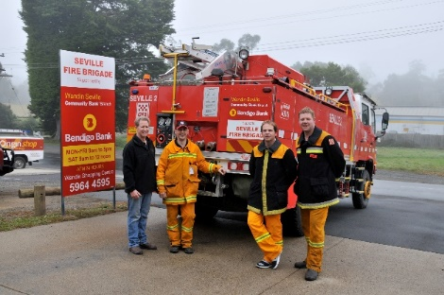
Community Bank® Branch
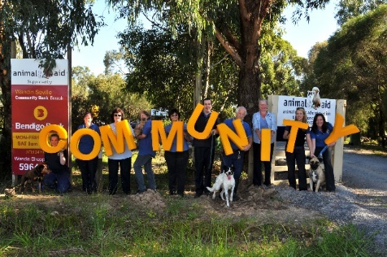

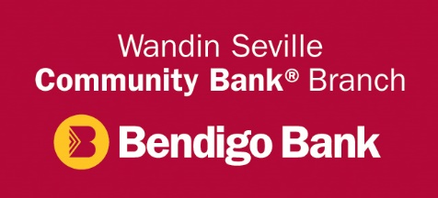

Sponsorship Application Form
Once completed please return to:
Executive Officer
Wandin Seville Financial Services Limited
Shop 1, Lot 10 Union Road. Wandin North, VIC 3139
Email: executive.officer@wandinsevillefinancialservices.com.au
Organisation/Group applying for sponsorship:
Australian Business Number (ABN) Number of members in your organisation/group
Is your organisation a not for profit?(Please circle one)  (All applicants must be an incorporated body or auspiced by an incorporated body) | YES NO
Postal Address:
Contact Name and Position Held:
Email Address:
Contact Ph:
Amount Being Requested: $ | (including GST)
What is it to be used for? (Project, Event, Equipment etc.) Brief Description. |  | Please include an estimated total project cost & timeline if applicable.

Date of Event ______________________________
Are you seeking sponsorship from other sources? YES NO
If YES - Where from:
Positive outcomes for your organisation from this sponsorship
Positive outcomes for the community
Do you currently bank with the Wandin Seville Community Bank® Branch? YES NO

If no – would you consider opening an account? YES NO

We rely on the profits made through banking at our Community Bank® Branch to enable us to have funding to sponsor local organisations.

Positive outcomes for Wandin Seville Community Bank® Branch
(How will you be able to recognise and promote this sponsorship)
□ At Events/Programs - Wandin Seville Community Bank® Branch sign/logo placement
□ Permanent display of sign and / or banner at sporting ground/club room/premises
□ Acknowledgment of sponsorship in your newsletter, Facebook, Website? ______________________________
□ Acknowledgment of support on our Facebook page (Wandin Seville Community Bank® Branch)
□ Do you require Wandin Seville Community Bank® Branch representatives to attend event/award function? (if yes, please provide details in your covering letter)
□ Other ways your group will promote our Company/Community Bank® Branch?
Signed: Date:
Full Name: (Please print)

GENERAL INFORMATION

Wandin Seville Community Bank® Branch is owned by a community company called Wandin Seville Financial Services Ltd, backed by local shareholders and run by a board of volunteer directors under a franchise arrangement with Bendigo Bank. Our focus is to provide a competitive, local community focused banking service generating funds to support local community projects.  It is important that the Wandin Seville Community Bank Branch attracts support from the local community in order to generate profits which are returned to the local community. This is a unique system which is absolutely community focused unlike any other banking system.  For this system to succeed it is essential that our sponsorship dollars generate support for the Wandin Seville Community Bank® Branch.  Wandin Seville Financial Services Ltd are to be the sole source of sponsorship from any financial institution for the project applied for unless due to exceptional circumstances where the board would consider such and render a decision accordingly.  Organisations, clubs or community groups applying must be incorporated, should have an ABN and be able to demonstrate an appropriate level of fiscal responsibility. Priority is given to organisations based in Wandin, Seville, Wandin North, Wandin East, Seville East, Gruyere, Silvan, Coldstream and Lilydale but not limited exclusively to these areas.  All requests for sponsorship will be presented to our marketing committee for consideration. Meetings are held on the second Tuesday of each month and applications need to be submitted two weeks prior. A time will be arranged for a representative of the applicant to attend the meeting.  If successful, the applicant must provide a detailed invoice to Wandin Seville Financial Services Ltd for the amount approved. In most cases payment will be made direct to the provider of the goods.  An acquittal form will be sent to you approximately 4 weeks after payment this must be completed and returned within 14 days. |  | What can be funded:  - Child, youth and family activities.  - Public health, safety programs and services  - Community capacity building projects  - Public education, school infrastructure facilities  - Innovative community services  - Cultural and arts initiatives  - Environment al projects  Wandin Seville Financial Services Limited will not support:  - Any political or religious event held solely to enhance the standing of said group.  - Any event or project that may denigrate, exclude or offend groups  - Programs that may present a hazard to the community  - Any form of weapons promotion  - Individuals  - Payment of salaries/ fees to individuals  - Provision of food or drink.  - Utility bills, rates, advertising etc., outstanding accounts, operational expenses  - Projects that have commenced or been completed prior to the application submission  Please note: Any major variation as viewed by Wandin Seville Financial Services Ltd from the sponsorship application outline may initiate a review of Wandin Seville Financial Services Ltd. funding agreement.  This is entirely at the discretion of Wandin Seville Financial Services Ltd. Therefore, it is essential that Wandin Seville Financial Services Limited be kept informed of any changes in a timely manner. This applies to the scope, costing, details and duration of the project as indicated in the sponsorship application.  If for any reason the project does not proceed as described, then any funds received from Wandin Seville Financial Services Limited for said project are to be immediately returned to Wandin Seville Financial Services Limited.  If you need to have a chat about your application, please do not hesitate to contact our Community Bank® Branch Manager or our Executive Officer and they will be pleased to talk to you about the sponsorship/grant process.

GRANTS CONTACT DETAILS

In addition to sponsorships Wandin Seville Financial Services Ltd have a grant process in place where as a philanthropic activity and part of our social responsibility program funds may be made available for specific community projects that would provide tangible benefits to the entire community without any commercial benefit returned to Wandin Seville Community Bank® Branch.  SCHOLARSHIPS  Wandin Seville Financial Services Ltd have a scholarship program to support students where due to financial or other circumstances educational opportunities are compromised. To initiate an assessment, contact our executive officer to arrange an appointment. | Branch Contact:  Wandin Seville Community Bank® Branch  Shop 3/10 Union Road  Wandin North VIC 3139  Jackie Butler. Branch Manager. Tel 03 5964 4595  E: Jackie.Butler@bendigoadelaide.com.au  Admin Contact:  Wandin Seville Financial Services Limited  Shop 1/10 Union Road  Wandin North VIC 3139  E: executive.officer@wandinsevillefinancialservices.com.au

Privacy Bendigo and Adelaide Bank Limited is committed to ensuring your privacy is protected and understands your concerns regarding the confidentiality and security of the personal information you provide. The information contained in this form will be held by the Wandin Seville Community Bank® Branch and may be disclosed to Bendigo Bank and organisations that carry out functions on behalf of Bendigo Bank. Our full privacy policy is available online at www.bendigobank.com.au. Bendigo and Adelaide Bank Limited. ABN 11 068 049 178 AFSL237879 . S53565 (280933 _v5) (8/ 05/ 2019)

